EXP 1 : BUILD A LAN TOPOLOGY IN CICSCO POCKET TRACER

OBJECTIVE 1 : STAR TOPOLOGY

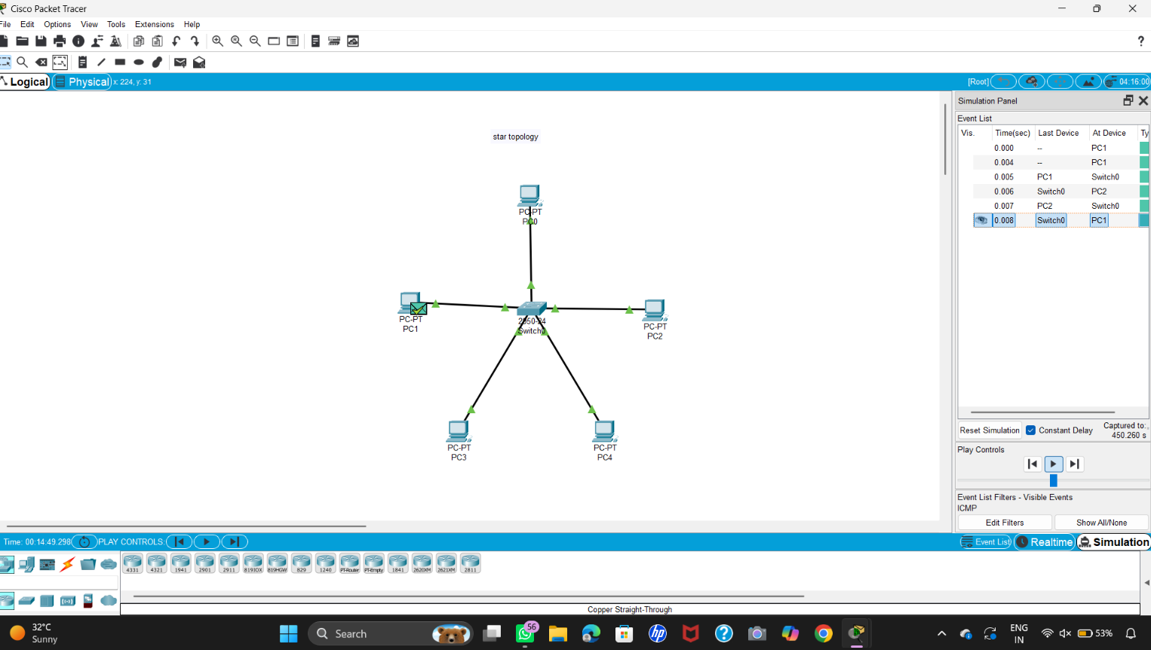

OBJECTIVE 2 : MESH TOPOLOGY

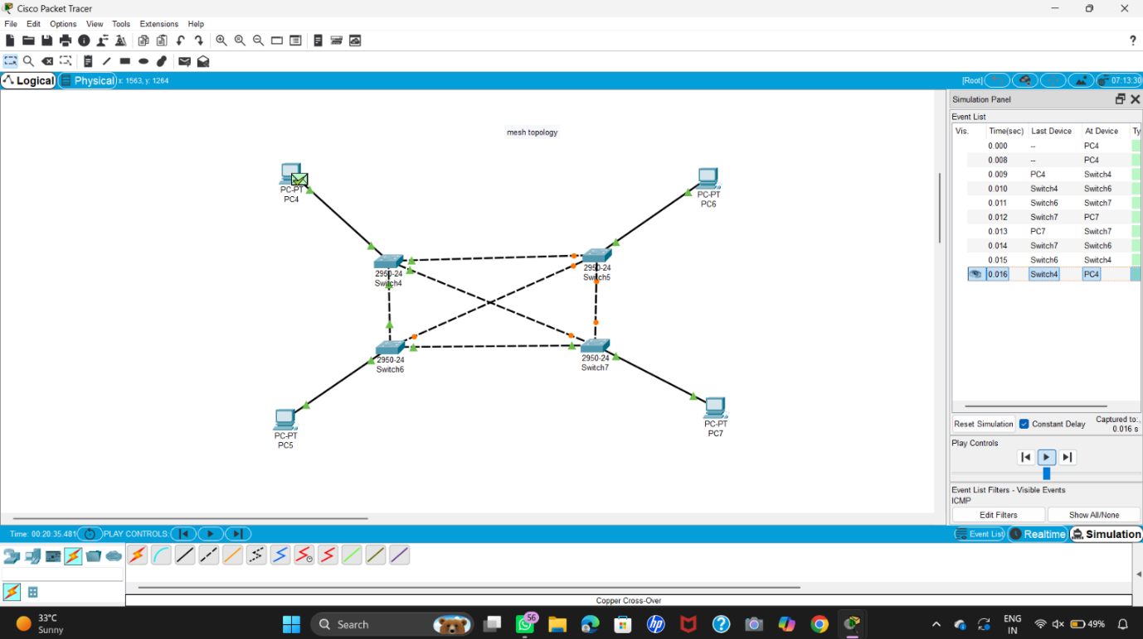

OBJECTIVE 3 : HYBRID TOPOLOGY

